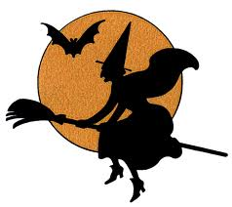
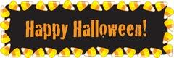
Friendshop’s Halloween Bash!

Do you have a child(ren) in Elementary school? Are you looking for FREE and fun educational activities to do with your child? If so, join us at FRIENDSHOP! Since our theme is Halloween, dress up in your favorite super hero, movie character, or any costume you would like and join us for an exciting night filled with boo-tastic activities!

Please join us on October 30th, 2012 at 7:15-8:30, at the East Lansing Public Library.

Activities include:
- Face painting
- Pumpkin painting
- Coloring activities
- Much more!

Friendshop is directed by Stephanie Dye a student in the College of Education at Michigan State University. For any questions or concerns feel free to contact her at dyestep1@msu.edu
